**A Mini Project Report**

**on**

**“e-Fertilizer Store”**

Submitted by

**33326 - Shubham Garje**

**33329 - Shubham Ghule**

**33331 - Amol Gore**

**33338 - Vaibhav Kanade**



Department Of Information Technology

Pune Institute of Computer Technology College of Engineering

Sr. No 27, Pune-Satara Road, Dhankawadi, Pune - 411 043.

**A.Y. 2020-2021**

**Abstract**

In this project we created one web application which is easy to access and user-friendly. For this application we used the backend as Nodejs and MySQL to store the data which is used in the application and for the user interface we had used the express js. Two kinds of people are able to use this website as admin and the customer as well. The customer(farmers) is able to do the online shopping very easily from any place by reading the details of the product(fertilizers) and by seeing the product image and information. The admin is the only person who is able to add and remove the products from the site.

**Acknowledgement**

We are highly indebted to Prof. Ravindra Murumkar for their guidance and constant supervision as well as for providing necessary information regarding the project & also for their support in completing the project.

We would like to express my gratitude towards my parents for their kind cooperation and encouragement which help me in completion of this project. We would like to express my special gratitude and thanks to industry persons for giving me such attention and time.

Our thanks and appreciations also go to our faculties in developing the project and people who have willingly helped us out with their abilities.

**(Students Name & Signature)**

**Shubham Garje**

**Shubham Ghule**

**Amol Gore**

**Vaibhav Kanade**

**CONTENT**

|  |  |  |
| --- | --- | --- |
| Sr No. | Title | Page |
| 1. | Abstract | 02 |
| 2. | Acknowledgement | 02 |
| 3. | Introduction | 04 |
| 4. | Overview | 04 |
| 5. | Background and Motivation | 04 |
| 6. | Methodology | 06 |
| 7. | Scope | 06 |
| 8. | Requirements | 06 |
| 9. | ER diagram | 08 |
| 10 | Database Schema | 08 |
| 11. | Relational Database Tables | 09 |
| 12. | Graphical User Interface | 12 |
| 13. | Conclusion | 18 |
| 14. | Reference | 19 |

**INTRODUCTION**

Fertilizers play an important role in growth of plants. Farmers require fertilizers as it nourishes soil with nutrients and minerals. Farmers take different crops throughout a year. To grow healthy and good quality crop soil must contain required nutrients.

If fertilizers are not used, they may result in poor quality crops which would ultimately put farmers in trouble as their produce will not get a good price.

Through our project we have tried to make available different types of fertilizers at affordable prices to farmers at one place.

**Overview: -**

This report discusses the result of the work done in development of "eFertilizer Store” on “Node js” Front-end Platform and “MySQL” as a back-end Platform. Node js provides a good connecting facility between all pages, also the back-end, i.e., MySQL is most important to save all the data related to the application.

**Background and Motivation**

Plants need to be fertilized because most soil does not provide the essential nutrients required for optimum growth. Even if farmers get good produce for the first time, as plants grow, they absorb nutrients and leave the soil less fertile. It took nutrients from the soil to build those plant tissues. By fertilizing the farmland, it replenishes lost nutrients and ensures that this year's plants have the food they need to flourish.

**Conventional system: -**

Farmers need to go to another village or city to get required fertilizers and also end up paying more price to many middle men like brokers and others.

**Technical system: -**

It provides a graphical UI based system to buy fertilizers. Farmers can select from a variety of products and get them delivered at their doorstep.

**Objective: -**

Need of e-Fertilizer Store : -

1) all products at one place.

2) Convenience and affordable prices

3) Saves time and money

4) Provide Farmer many options

**METHODOLOGY**

To implement the above goals, the following methodology needs to be followed:

1. Specifying the Application and various components of the Architecture.

2. Specifying the bindings between the tasks and the resources either manually or by the design tools.

3. Specifying the port interconnections between the resources.

**Scope of Project: -**

The scope of the project is to give a simple and attractive software to simplify the work as well as to reduce the efforts while doing it by traditional means. In this application we are able to provide many fertilizers at one place and at affordable prices for all.

**Requirements: -**

We are going to perform the project on windows / ubuntu / mac OS platform so we need any one of the above OS. Any version of windows as windows XP, windows 7 or windows 8 or ubuntu 15.0.0 and above or macOS 9 or above. The system should have a minimum ram of 256MB as well as minimum storage capacity of 15GB.The system should contain the server software named as “Node”. And MySQL DB of version 3.6.3 or above. First, we have to install both software and we have to do connectivity between them by changing the configuration file of “Node”.

**ER Diagram**

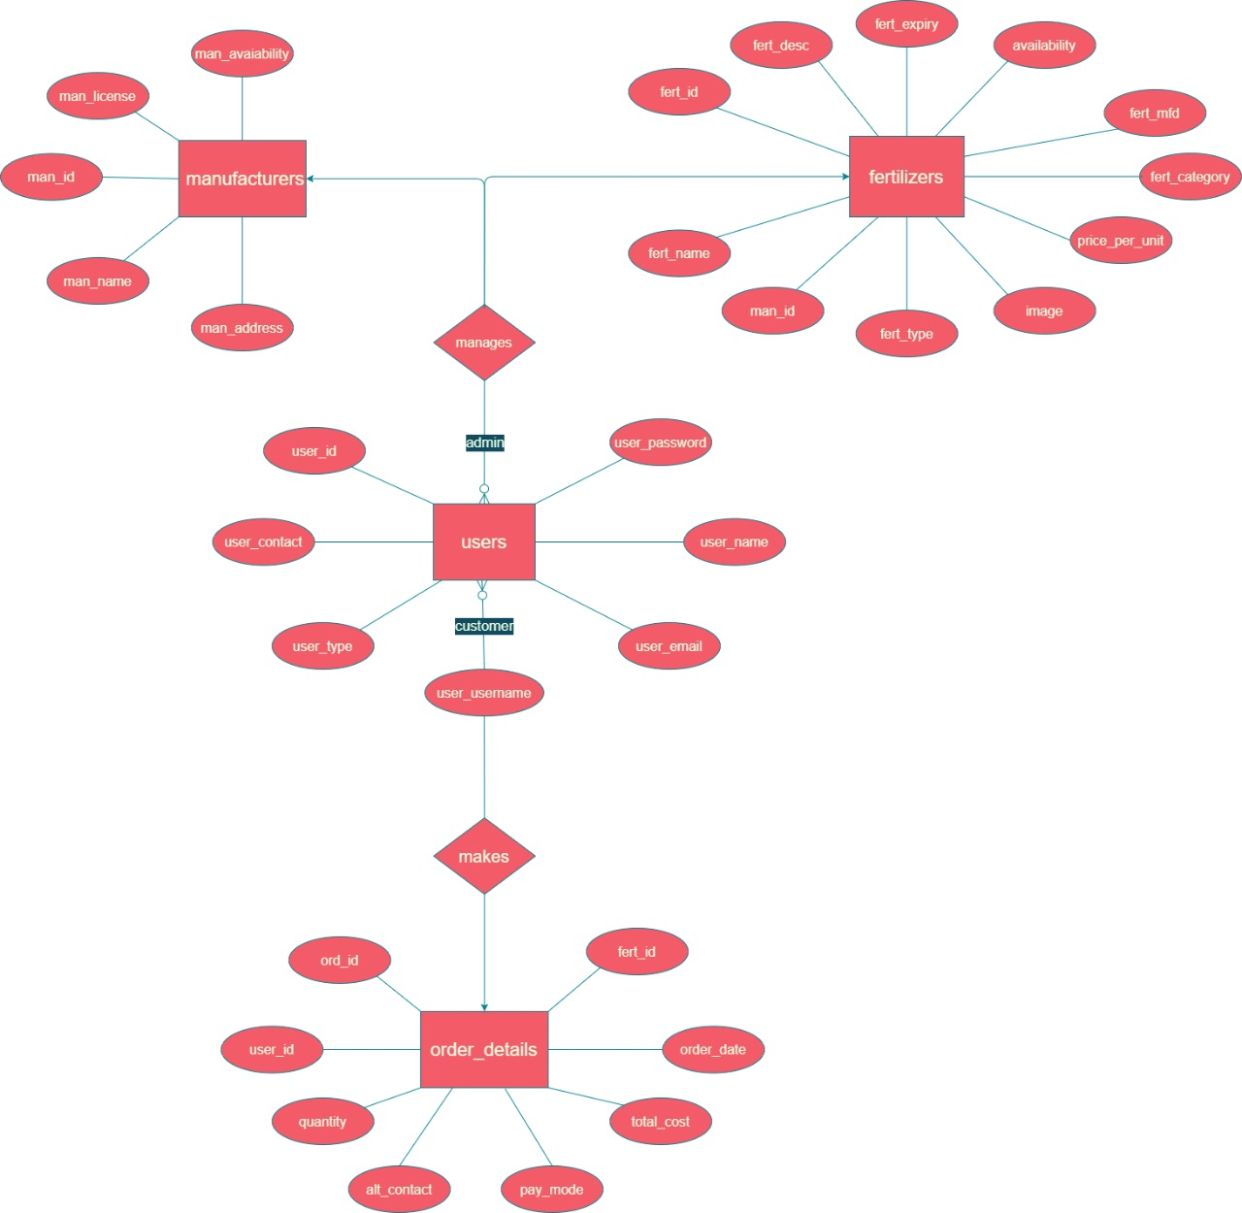

**Database Schema**

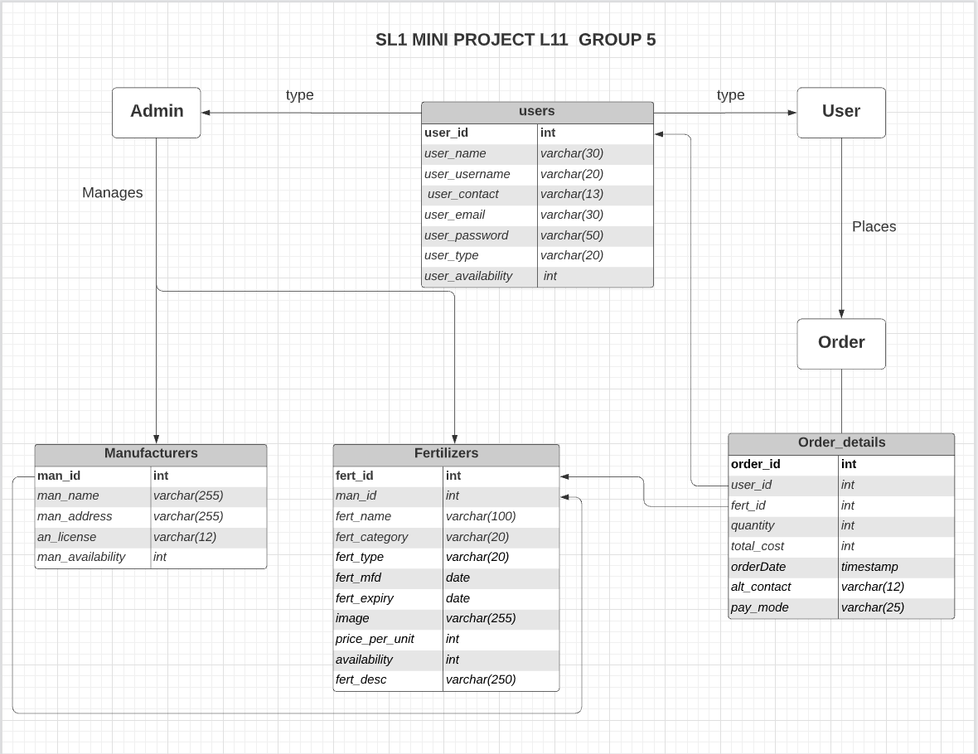

**Tables :**

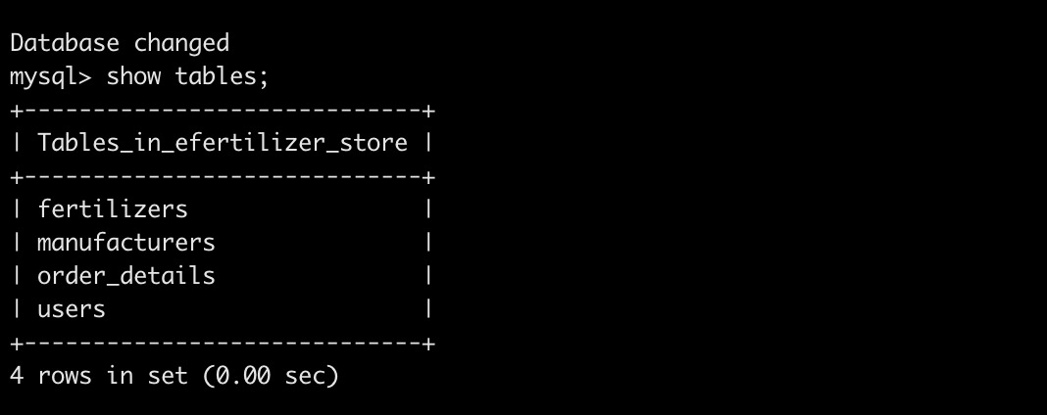

**1. Users**

|  |  |  |  |  |  |  |
| --- | --- | --- | --- | --- | --- | --- |
| user_id | user_name | user_username | user_contact | user_email | user_password | user_type |

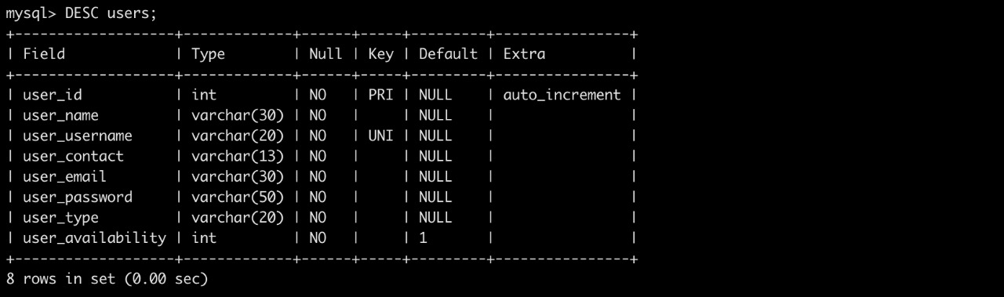

**2. Manufacturers**

|  |  |  |  |
| --- | --- | --- | --- |
| man_id | man_name | man_address | man_license |

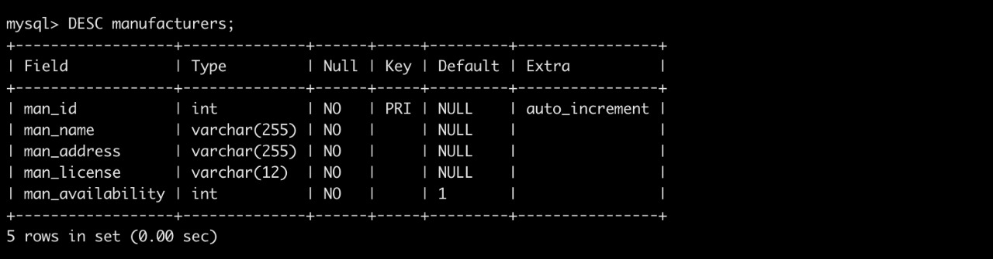

**3. Fertilizers**

|  |  |  |  |  |  |  |
| --- | --- | --- | --- | --- | --- | --- |
| fert_id | man_id | fert_name | fert_type | fert_category | fert_mfg | fert_desc |

|  |  |  |  |  |  |
| --- | --- | --- | --- | --- | --- |
| fert_expiry | stock | image | fert_type | price_per_unit | availability |

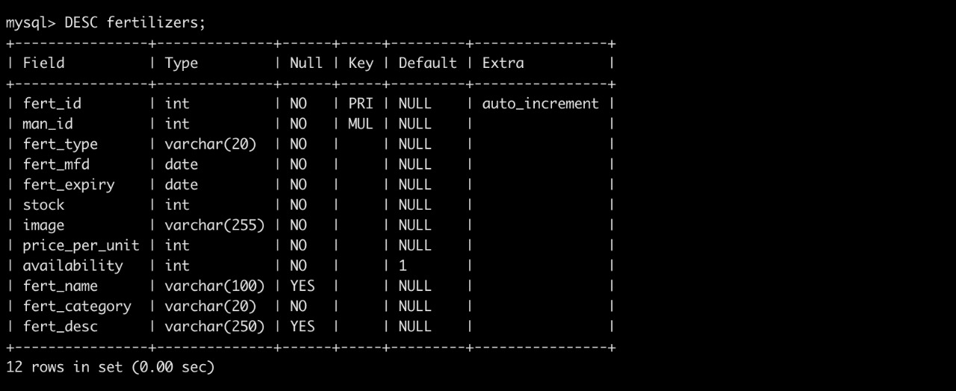

**4. order_details**

|  |  |  |  |  |  |  |  |
| --- | --- | --- | --- | --- | --- | --- | --- |
| order_id | user_id | fert_id | quantity | total_cost | order_date | alt_contact | pay_mode |

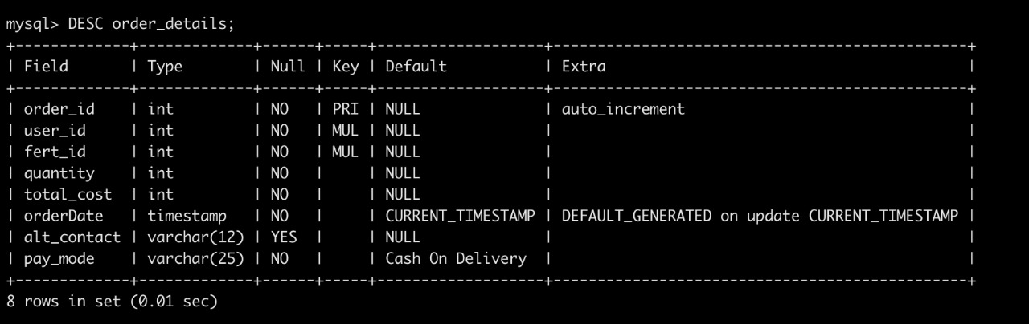

**Graphical User Interface**

The application is very user friendly and uses a GUI interface implemented in expressjs to Communicate with the user. Various features are self – explanatory. Forms are easy to fill in and product info can be added, removed and updated by admin very easily through an admin dashboard.

Many cards are used to display all the products at once so that users can see many products on one page. One can just select the product and proceed to buy and pay . (based on the access control of the person)

**Snapshots: -**

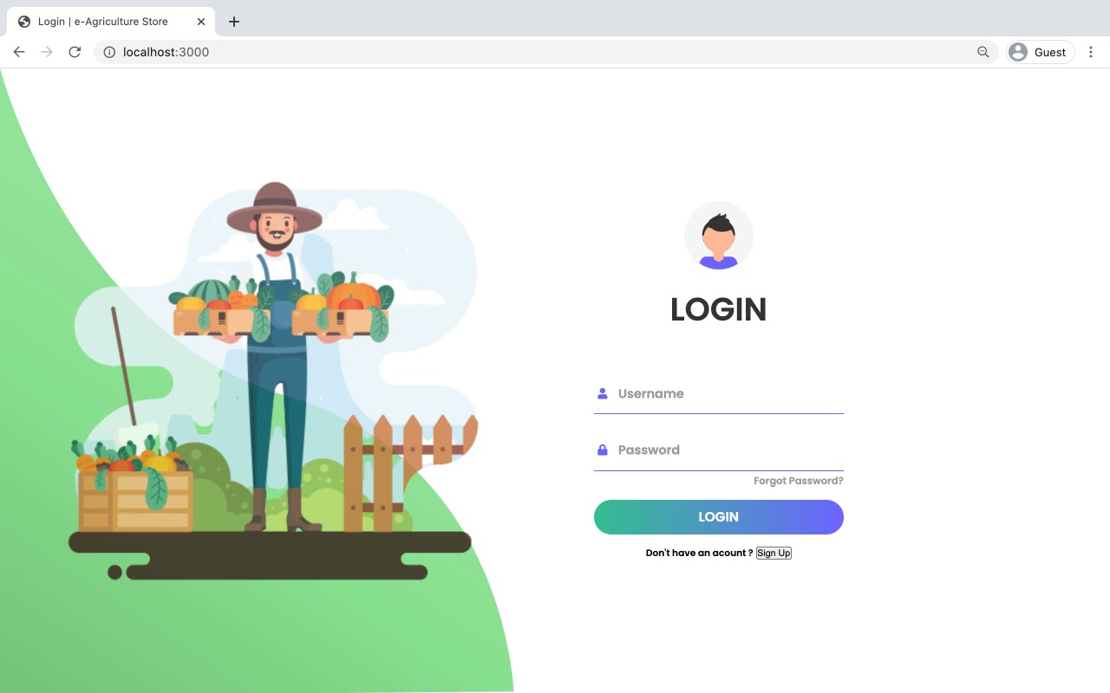

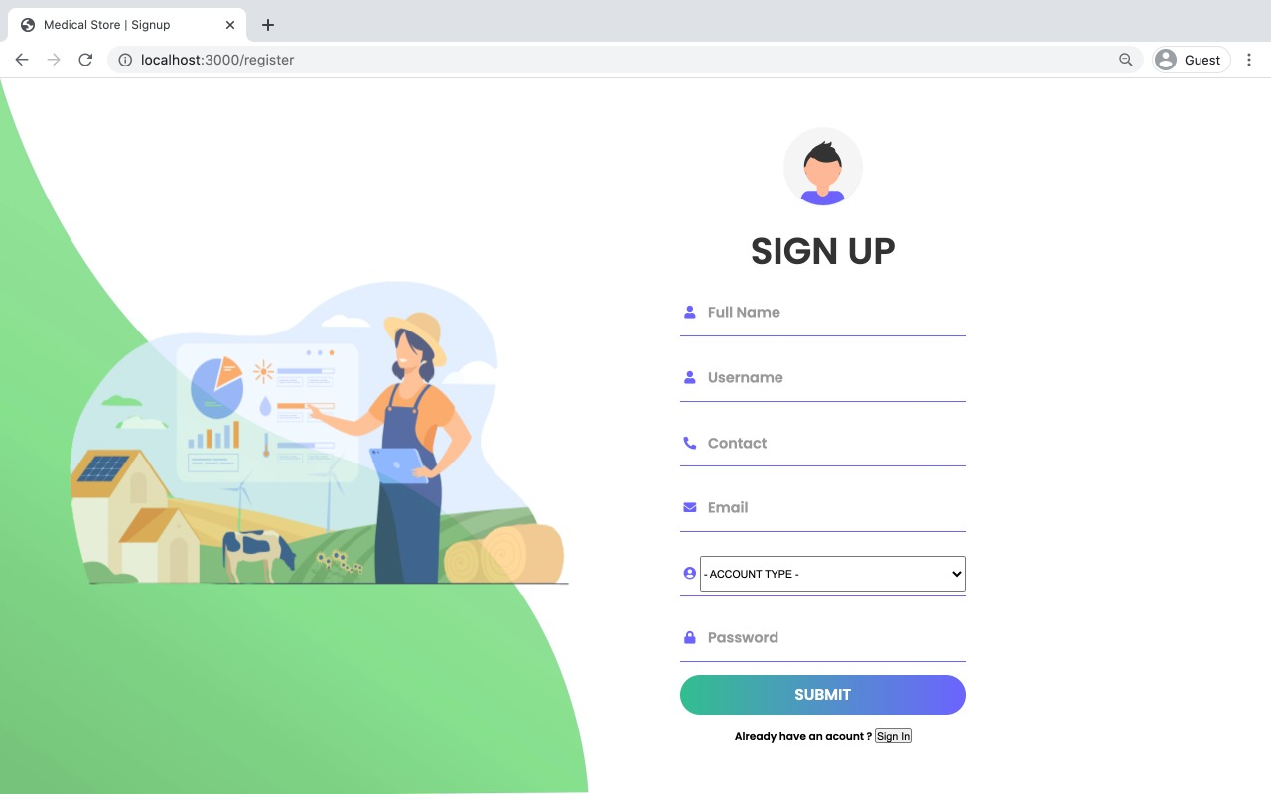

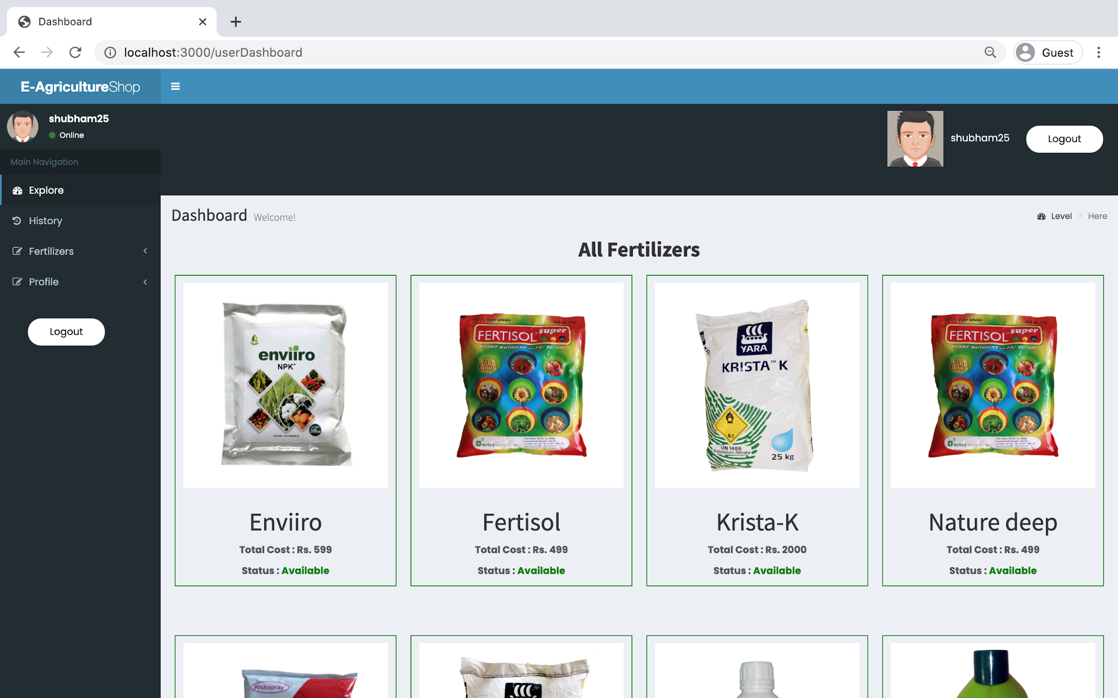

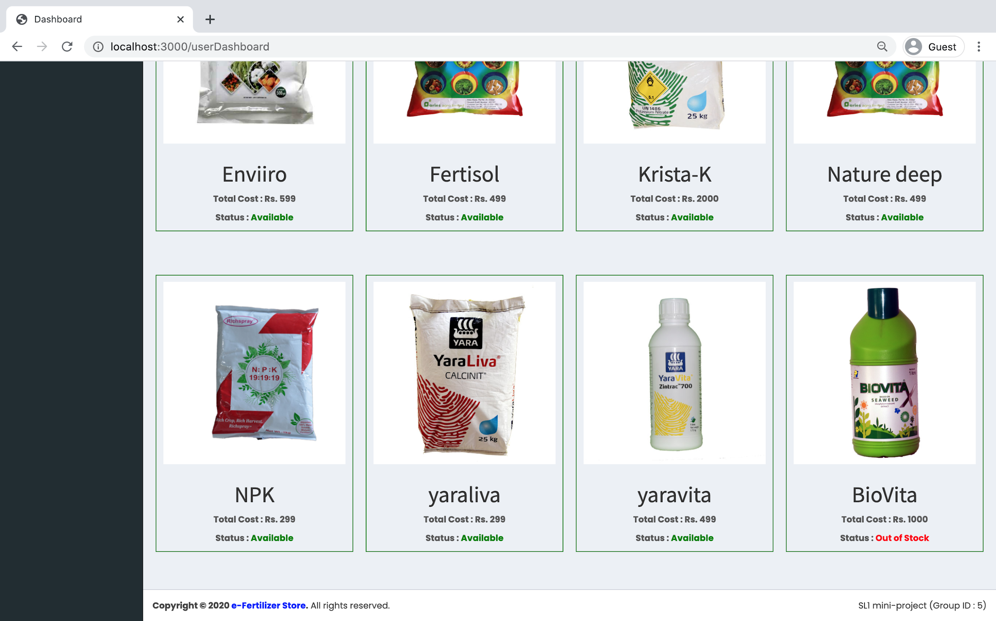

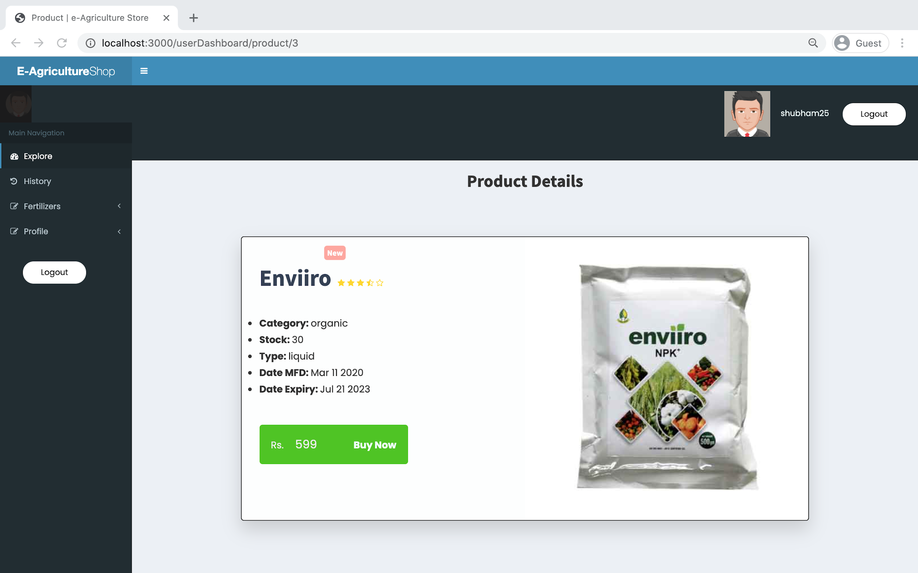

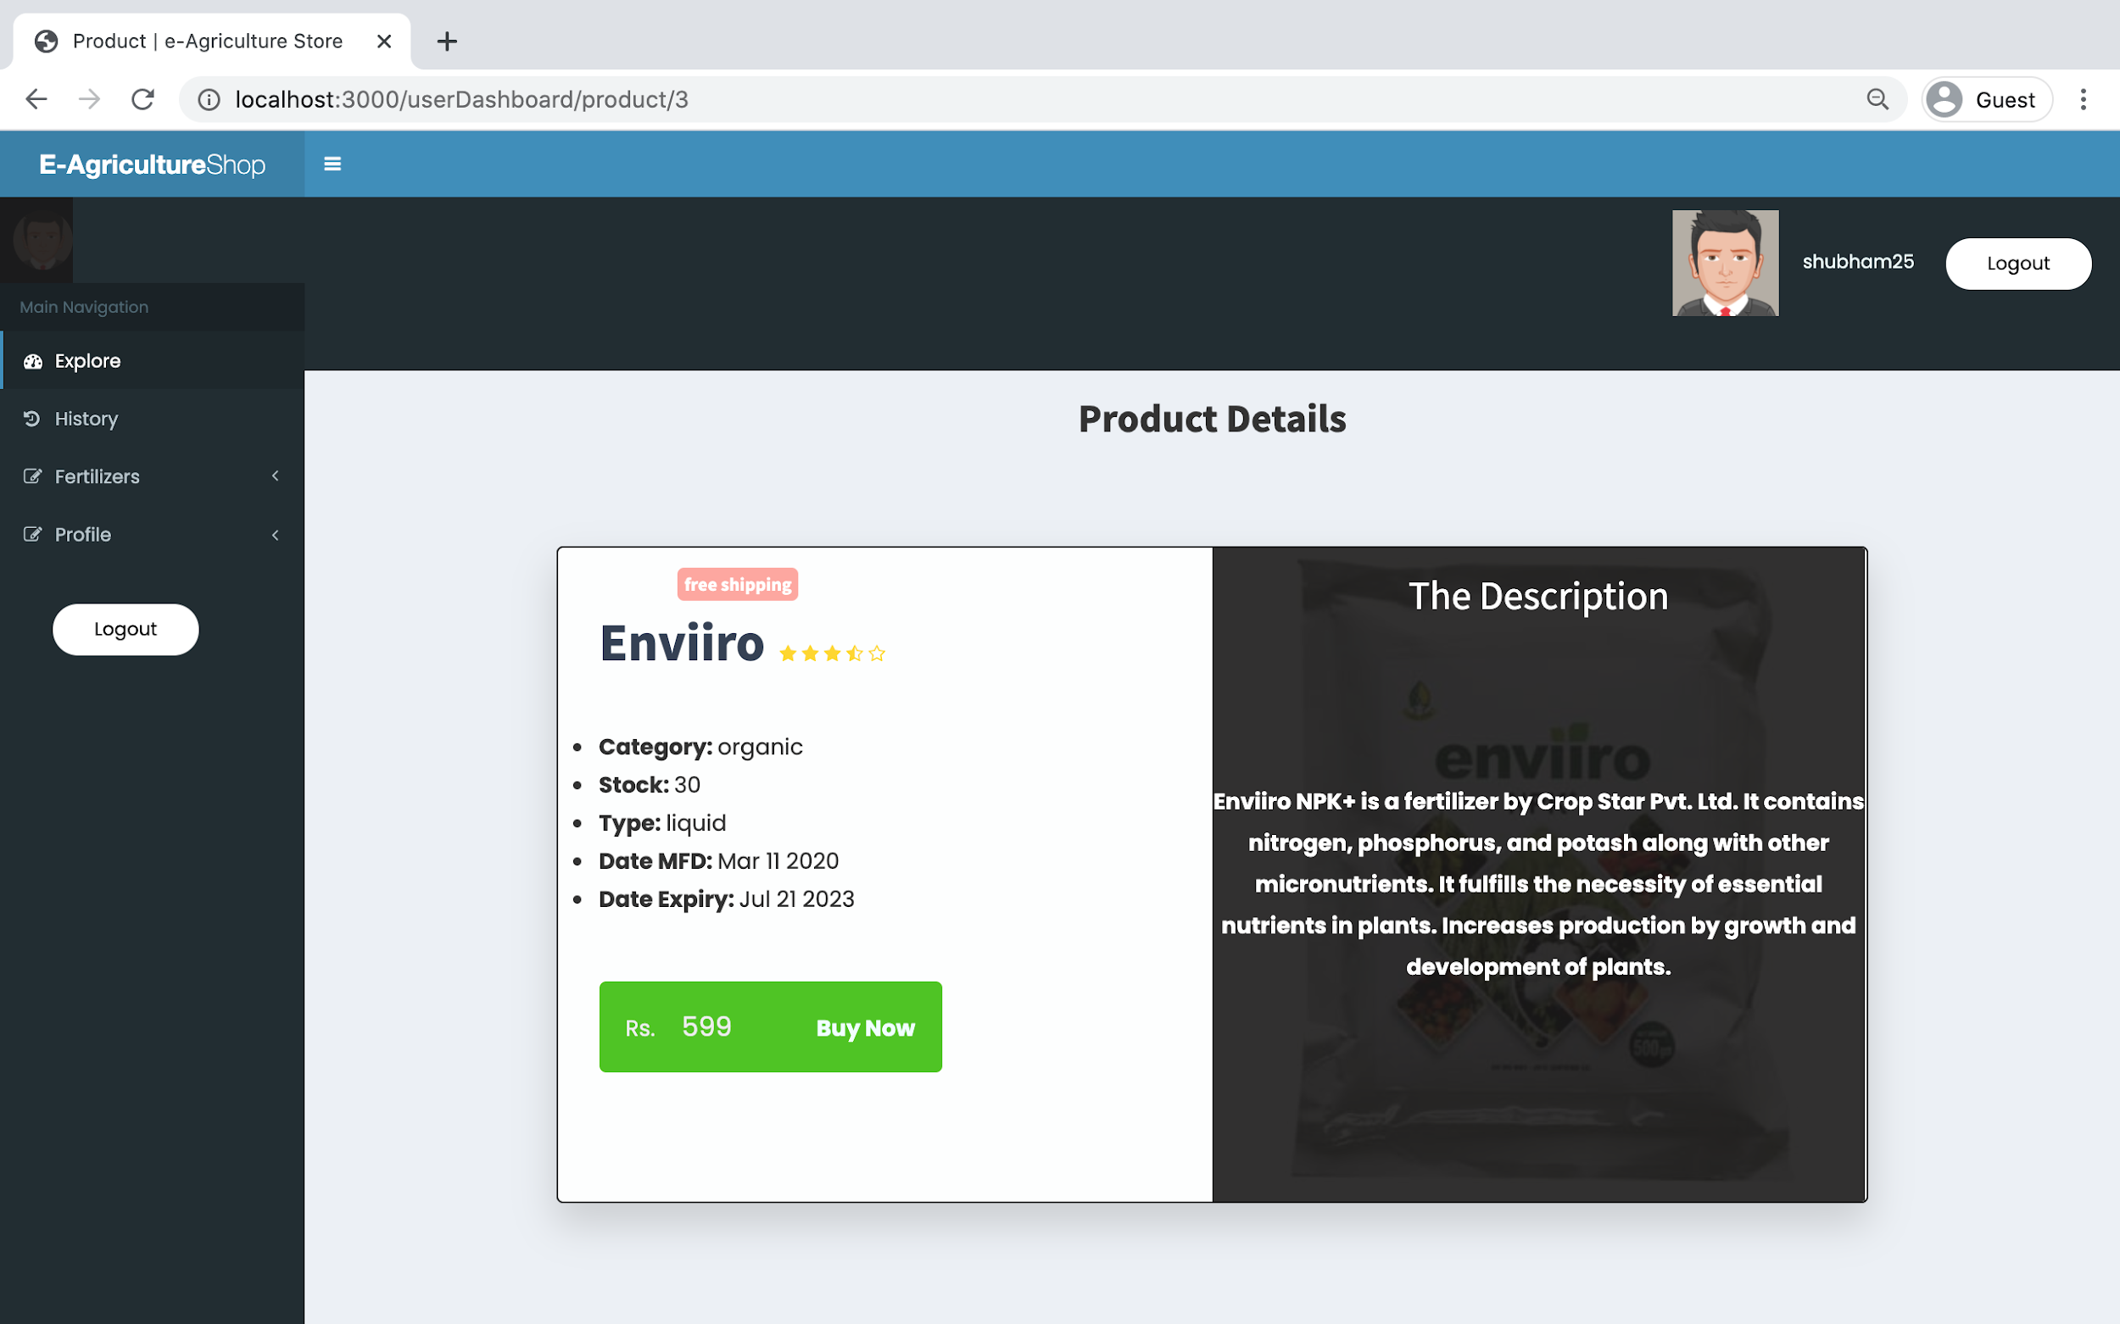

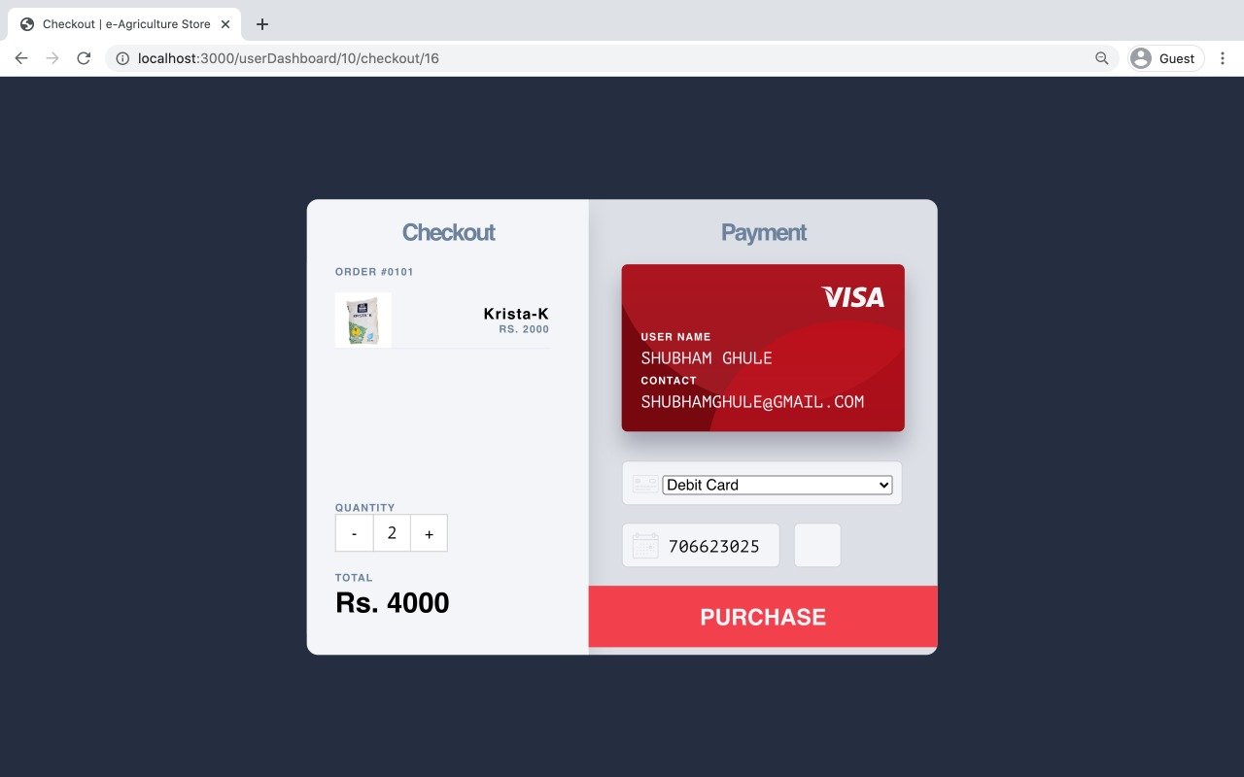

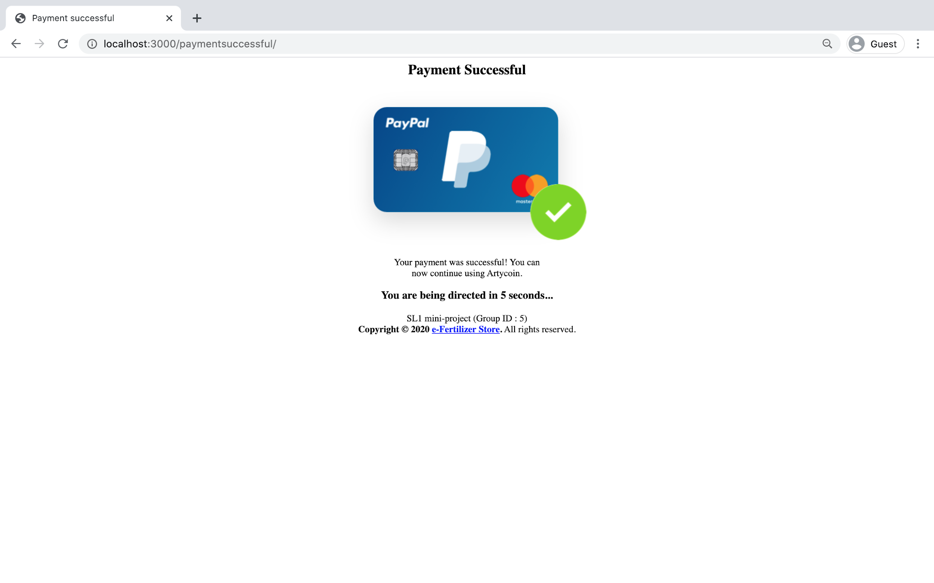

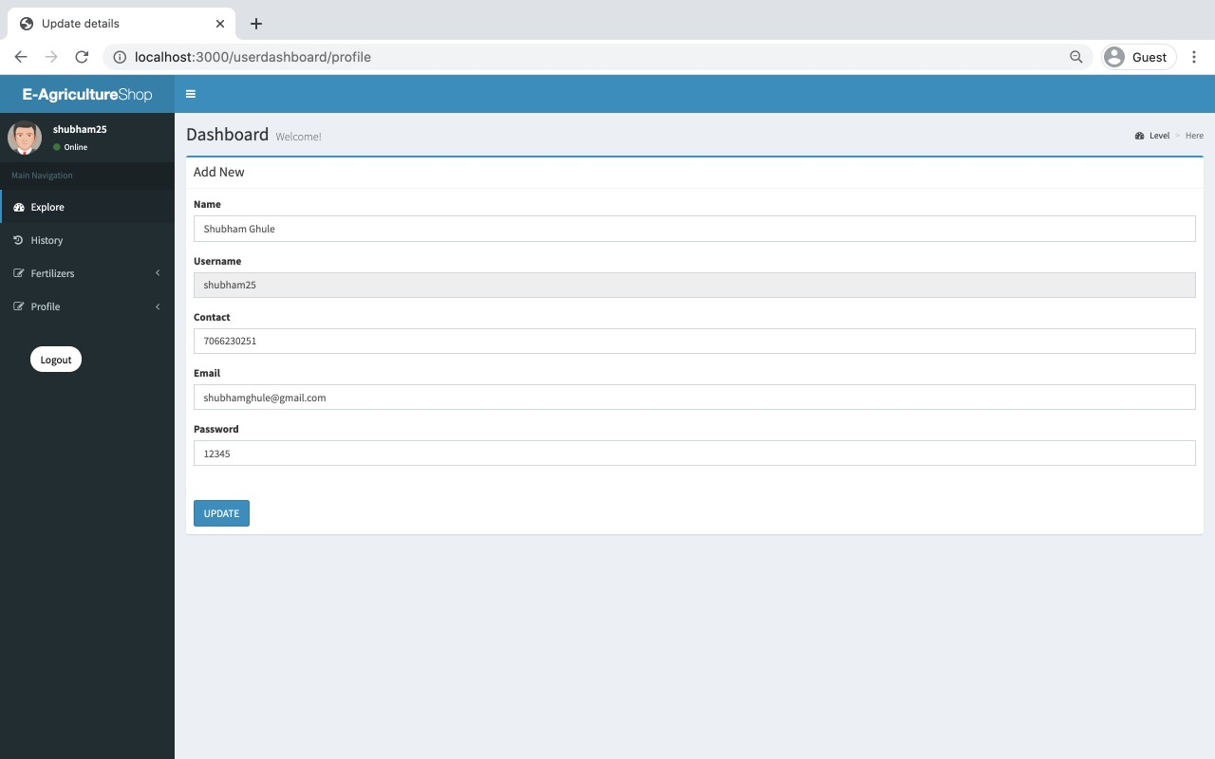

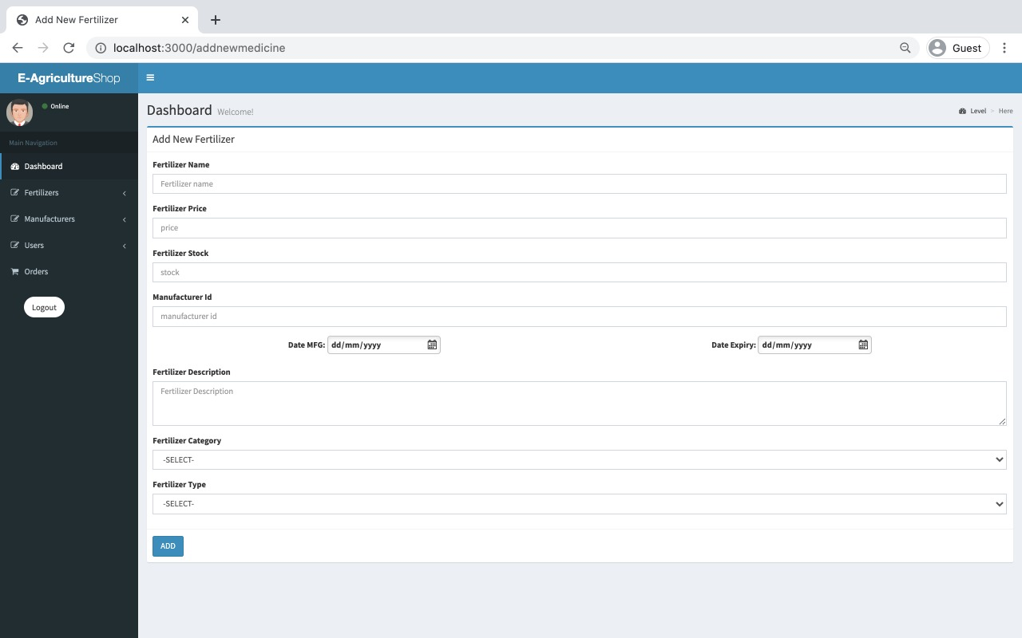

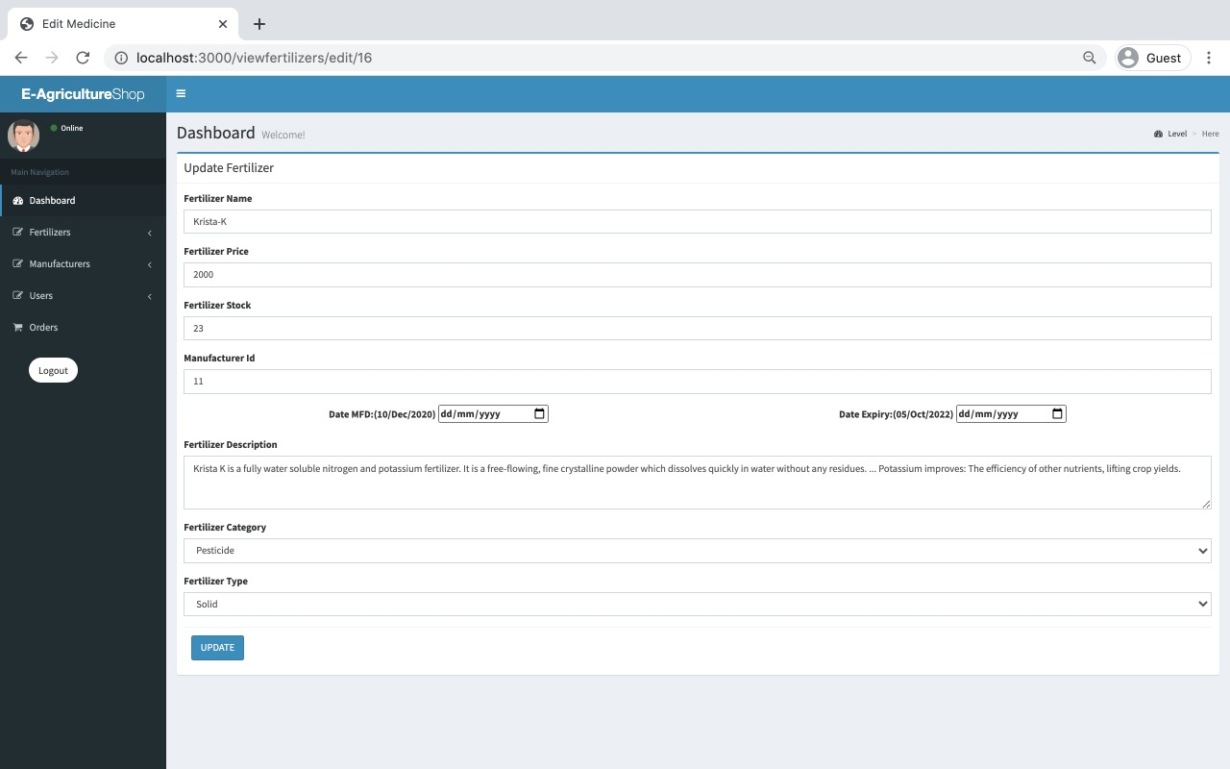

**Features: -**

1. Clean separation of various components to facilitate easy modification and revision.

2. All the data is maintained in a separate file to facilitate easy modification

3. Modularized design for user and admin to update and modify.

4. Quick and easy saving and loading of database file.

**Future Scope: -**

1. Add Live Search option
2. To generate invoice / bill.
3. To generate sales reports for a given time span.
4. Track order status.

**Conclusion: -**

Thus, we have successfully implemented eFertilizer Store, an ecommerce website from where farmers can buy fertilizers.

We have successfully implemented various functionalities of MySQL and Node and created the fully functional database management system for e-commerce websites.

**Tech Stack : -**

1. MySQL - (database backend)
2. EJS - (framework)
3. NodeJS - (connectivity)

**Software Used : -**

1. visual studio code
2. node
3. github

**References** : -

1. YouTube tutorials.
2. Google
3. 1mg website
4. Various E-Commerce Websites